**Name:** Files\\Grey Literature\\Case Study\\Pearl Automation

¶1: **Startup Failure Post-Mortems 2017 Third Update (10/31/17)**

### ¶2: Pearl Automation

¶3: Title: [Auto startup Pearl shuts down](https://www.axios.com/automotive-startup-pearl-is-shutting-down-2448087174.html)  
¶4: Title Link: <https://www.axios.com/automotive-startup-pearl-is-shutting-down-2448087174.html>

¶5: Product: [Pearl Automation](https://www.cbinsights.com/company/pearl-automation)‘s wireless rear-view camera  
¶6: Product Link: <https://www.cbinsights.com/company/pearl-automation>

¶7: Pearl’s demise was first reported by Axios.

* ¶8: What happened: Early product sales disappointed, which was exacerbated by a high burn rate.
* ¶9: What next? The Pearl Automation team received several “acqui-hire” offers, but opted instead to shut down and part ways, according to a source close to the situation.
* ¶10: Background: Pearl was founded in 2014 by three ex-Apple iPod engineers, and hired dozens of other ex-Apple employees. It eventually settled on the wireless rear-view camera as a first step in developing autonomous driving technology — and raised $50 million in VC funding from Accel, Shasta Ventures, Venrock, and Wellcome Trust.

# ¶11: Pearl Automation

¶12: AUTOMOTIVE & TRANSPORTATION | Automobile Parts  
¶13: [pearlauto.com](https://pearlauto.com/)

## **¶14:** Founded Year

¶15: 2014

## **¶16:** Stage

¶17: Dead | Dead

## **¶18:** Total Raised

¶19: $50M

## **¶20:** About Pearl Automation

¶21: Pearl Automation is focused on advancing the underlying technologies in the autonomous vehicle to improve the experience for every driver on the road today. The Company's first product, RearVision, is an advanced automotive backup camera that connects to a driver's smartphone via wi-fi. RearVision installs in minutes, provides obstacle alerts and updates automatically to deliver ongoing feature enhancements.

## **¶22:** Pearl Automation Headquarter Location

¶23: 100 Enterprise Way Suite A101

¶24: Scotts Valley, California, 95066,

¶25: United States

¶26: 844-877-3275

¶27:

¶28: Exclusive: Auto startup Pearl shuts down

¶29: Dan Primack, Kia Kokalitcheva Jun 26, 2017 – Technology  
¶30: Title Link: <https://www.axios.com/automotive-startup-pearl-is-shutting-down-2448087174.html>

¶31:   
¶32: 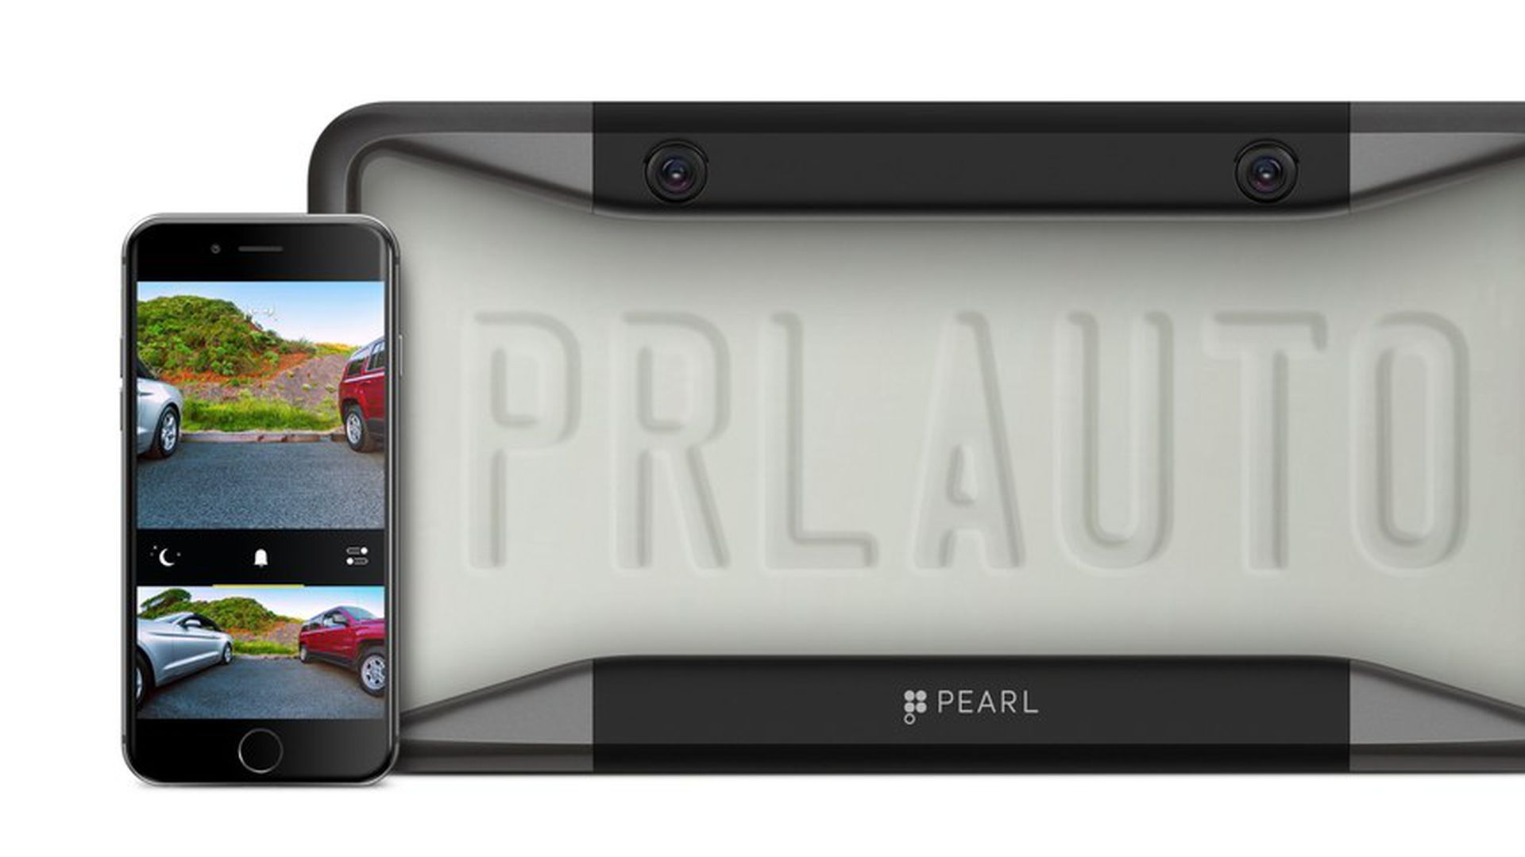

¶33: Courtesy of Pearl Automation

¶34: Pearl Automation, an automotive startup founded by former Apple engineers, has decided to shut down, Axios has learned from multiple sources. The move comes just a year after the company unveiled its first product, a wireless rear-view camera, which began to ship last September.

* ¶35: **What happened:** Early product sales disappointed, which was exacerbated by a high burn rate.
* ¶36: **What next?**The Pearl Automation team received several "acqui-hire" offers, but opted instead to shut down and part ways, according to a source close to the situation.
* ¶37: **Background:**Pearl was founded in 2014 by three ex-Apple iPod engineers, and hired dozens of other ex-Apple employees. It eventually settled on the wireless rear-view camera as a first step in developing autonomous driving technology – and raised $50 million in VC funding from Accel, Shasta Ventures, Venrock, and Wellcome Trust.